1) Explain SDLC at a high level

The general steps that taken to build software, feasibility, requirements, design, code, Test, Deploy, and Operate.

2) What is waterfall and why it is still relevant

This A linear software model that follows a top down approach, each step has to be completed to go to the next. This is still relevant because it saves time and money and progress can be easily measured.

3) Explain Agile Model with a use case and the role of SCRUM in that

A combination of incremental process. Agile methods break the product into small incremental builds. Scrum is a methodology for getting work done with an agile mindset

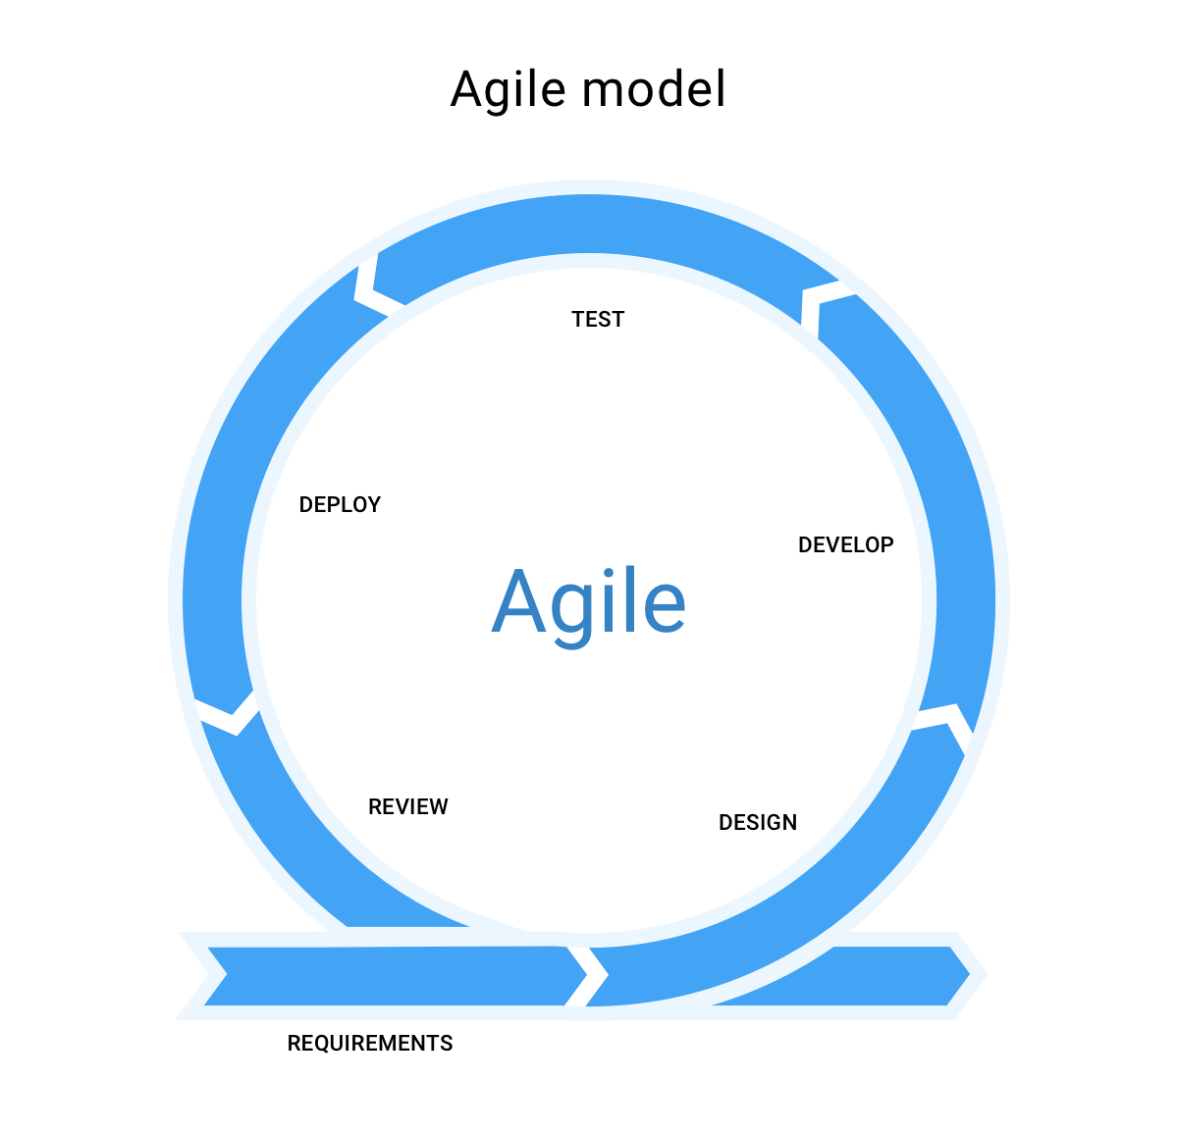

4) Who is Scrum Master

He will try implement the Scrum methodology within the team, “running the show” , help everyone understand the Scrum principles and methodology.

5) Differentiate between Product/Sprint Backlog

A product backlog is a list of all the things that must be done to complete the entire project. The sprint backlog is a subset of the product backlog that contains only those items that can be completed in that sprint.

6) What is Epic & Story

An epic is a piece of product functionality that is to big to be completed in one sprint. An story is a specific task within an epic

7) What is called Velocity in SCRUM

the amount of work a team can do in a sprint.

8) Explain the SCRUM ceremonies

Organize the backlog –

Sprint Planning – discuss the stories to do on the current sprint

Sprints – start working on sprints

Sprint Execution – the development

Daily Scrum/Stand Up – three questions asked for everyday scrum meeting

Sprint Review – reviewing the accomplished features in the sprint

Sprint Retrospective – overall analysis in that sprint

9) What is grooming

A Scrum team meeting that discusses the product backlog items and the next sprint planning

10) How Jira board is effective in SCRUM

Helps make managing sprints simpler and easier

11) Differentiate between SCRUM & Waterfall

Waterfall is sequential and has a strict hierarchy. You can’t go to next stages without finish the previous which means you won’t identify a fail until the testing stage. SCRUM is more flexible and divided into sprints which allows the project properties to change after every sprint

12) Explain the responsibilities of Product Owner

The product owner is responsible for managing the product backlog such as creating epics and stories